**FishTank Ltd data migration to cloud**

**Executive Summary**

FishTank Ltd is on a journey to migrate their critical line-of-business application, PETRA, to the Amazon Web Services (AWS) cloud. This migration aims to enhance scalability, reliability, and performance for PETRA, a Customer Relationship Manager (CRM) application utilised extensively by over 5,000 users across the UK. This document outlines the proposed technical approach, schematic diagram, detailed pricing, and network design for the PETRA application migration.

**Introduction**

The decision to migrate FishTank Ltd's critical line-of-business application, PETRA, to the Amazon Web Services (AWS) cloud is underpinned by a strategic rationale aimed at achieving multiple business benefits. This brief overview outlines the key drivers for cloud migration, emphasizing cost reduction, scalability, disaster recovery, and improved accessibility. Subsequently, we delve into the detailed migration plan, highlighting the use of AWS services such as Direct Connect, Network Access Control Lists (NACLs), and Elastic File System (EFS) to ensure a secure, scalable, and fault-tolerant environment for PETRA. The holistic strategy encompasses not only the technical aspects of migration but also the broader business advantages that AWS cloud adoption offers to FishTank Ltd.

## **Rationale for Cloud Migration**

1. Cost Reduction: Elimination of on-premises infrastructure and maintenance costs leads to significant financial savings.
2. Scalability: Cloud adoption allows flexible scaling to meet varying workloads, crucial for post-production VFX work with tight project timelines.
3. Disaster Recovery: Cloud-based solutions provide a robust disaster recovery mechanism, minimising the risk of data loss and ensuring business continuity.
4. Improved Accessibility: Cloud migration facilitates seamless expansion into North America and APJC, enhancing global accessibility and opening doors to new markets.

**Cloud structure schematic**

The outlined plan illustrates our strategy for migrating all services to AWS. A brief overview reveals that AWS Direct Connect facilitates graphical user interface (GUI) access to all services, followed by routing through Network Access Control Lists (NACLs) to the router, acting as a network filter which meets the requirement for a firewall. Certain requests will require admin access, these requests will traverse through the directory service, and all requests are then passed through the router to the application load balancer and finally web servers and NAT gateways.

The load balancer ensures an equitable distribution of workloads among web servers. Simultaneously, the NAT gateway provides internet access to the private subnet. Within the private subnet, a communication link exists between the print server and the PETRA app servers. The PETRA application serves as a Customer Relationship Manager (CRM) and is connected to an Elastic File System (EFS) mount target linked to an EFS outside the availability zone within the VPC region to fulfil the shared storage requirement.

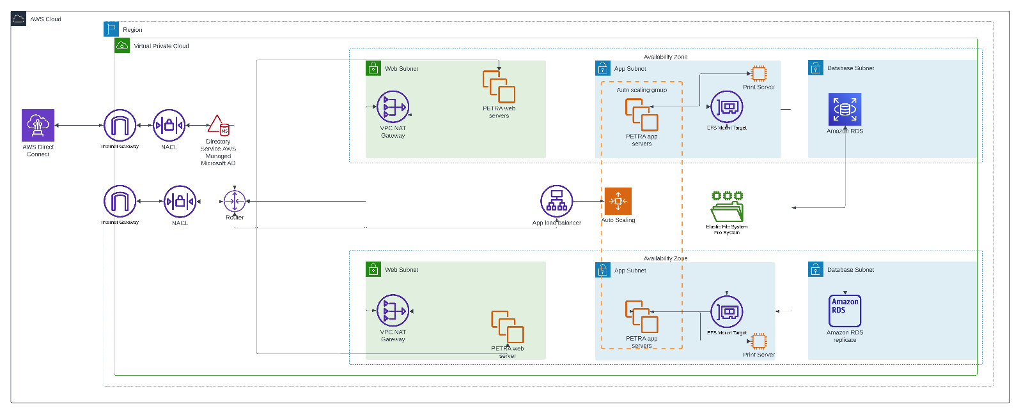In conclusion, the PETRA servers establish connectivity with Amazon RDS, serving as the SQL server for the internal database. To bolster fault tolerance, the web servers and PETRA app servers are strategically paired in two distinct availability zones. This arrangement includes two web servers and two PETRA servers in each zone, resulting in a total of four web servers and four PETRA servers. This configuration contributes to a resilient and fault-tolerant system, effectively reducing the likelihood of disruptions.

**Required Roles for migration and maintenance**

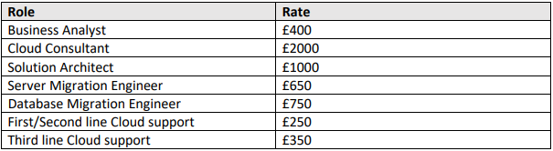

In order for FishTank to migrate PETRA to cloud, multiple contractors will be required to facilitate it. As seen above, the costs per role are given as a daily rate, project these to a monthly cost, and the total comes to £108,000 assuming 5 days a week for 4 weeks.

**Estimated AWS migration cost**

An estimation of the monthly cost for PETRA to be ran is detailed below:

|  |  |  |  |
| --- | --- | --- | --- |
| **Service Name** | **Upfront Cost ($)** | **Monthly Cost ($)** | **Region** |
| AWS Direct Connect | 0 | 16,425 | EU West (London |
| Amazon VPC | 0 | 577 | EU West (London |
| Load Balancing | 0 | 1,265.03 | EU West (London |
| EC2 | 0 | 16.64 | EU West (London |
| Amazon RDS | 0 | 2,429.44 | EU West (London |
| Amazon DMS | 0 | 1,047.46 | EU West (London |
|  |  | 21,761 |  |

The costs above are an estimation of the cost of running PETRA for one month using the architecture seen previously.

**Conclusion**

In conclusion, FishTank Ltd's decision to migrate the PETRA application to the Amazon Web Services (AWS) cloud is both strategic and financially sound. The meticulously outlined proposal, driven by key objectives such as cost reduction, scalability, and improved resilience, lays the foundation for a seamless transition to an advanced cloud infrastructure.

The anticipated labour cost of £108,000 for the initial setup is a crucial investment in the transformation process. This upfront expenditure is justified by the comprehensive benefits that the AWS cloud offers, ranging from enhanced scalability to robust disaster recovery mechanisms. As FishTank Ltd embraces the future of cloud technology, this strategic move not only addresses current business needs but positions the company for sustained growth and innovation.

The estimated monthly running cost of $21,761 aligns with the expected advantages of AWS services, emphasizing the efficiency gains and financial benefits of cloud adoption. This figure, when considered in conjunction with the initial labour investment, reflects a calculated and prudent approach to managing both upfront and ongoing expenses.

The proposal, encompassing technical details, schematic diagrams, and cost breakdowns, provides a holistic view of the migration plan. FishTank Ltd can confidently anticipate an optimized and cost-effective IT infrastructure, ensuring the continued success and resilience of the PETRA application in the dynamic business landscape.

As FishTank Ltd embarks on this cloud migration journey, the balance between the one-time labour investment and the recurring monthly cloud running cost sets the stage for a strategic, financially sustainable, and technologically advanced future. This proposal is not just an outline of technical details but a roadmap towards unlocking operational efficiency, cost savings, and long-term value through AWS cloud adoption.